These info pages of the document you can delete from the final document.

Action Acronym | EMIL
Grant Agreement number | 101070533
Action Title | European Media and Immersion Lab
Call | HORIZON-CL4-2021-HUMAN-01

Project European Media and Immersion Lab, co-funded from the European Union’s [Horizon Europe] Human research and innovation programme under grant agreement No 101070533, foresees as an eligible activity the provision of financial support to third parties, as a means to achieve its own objectives.
EMIL invites proposals especially for areas related to the core competences of the consortium partners (please see the figure below) and the four Lighthouse projects that reflect the expertise and supporting infrastructure of EMIL. However, XR-project proposals that are not directly related to these four areas will also be considered.
EMIL project invites proposals especially for areas related to the core competences of the consortium partners and the four Lighthouse projects that reflect the expertise and supporting infrastructure of EMIL. However, XR-project proposals that are not directly related to these four areas will also be considered.
- Wearable Haptic Interfaces for XR
Adding tactile sensations to XR has proved to enhance the immersive experience and has attracted tremendous attention from both academia and industry. EMIL develops smart garments (e.g., gloves and shirts) that combine vibrotactile, electrotactile and potentially also chemical stimulations to implement various tactile sensations and integrate stimulations into textiles. We will open source the designs of our smart garments and will provide open APIs for (re)configuring and (de)activating tactile sensations.
FSTP projects in this area are expected to focus on XR experience design utilizing the smart garments developed by EMIL or new designs of smart garments that provide different types of tactile sensations.
In either case, the proposed designs are expected to be prototyped and evaluated through user tests. Each FSTP project is free to choose any type of XR applications for demonstration and is encouraged to demonstrate the interplay between tactile sensation and other sensory modalities.
- Affective Exergaming in Virtual Environments
Virtual environments hold great promise in supporting users to be physically active. EMIL is developing technologies to enable gamified exercise ("exergames") in an effective and motivating manner, e.g., allowing users to interact naturally in virtual environments by cycling on an exercycle or running and jumping on the spot. Besides physical activity, our technologies make it possible to measure how users feel ("affect") and to adjust and optimise virtual environments accordingly. We demonstrate the value of these technologies in VR exergames for sports training and rehabilitation, optimising the user experience to be both physically engaging and emotionally motivating.
Possible FSTP projects include VR experiences that engage users through physical activity, e.g., for sport, rehabilitation and entertainment, and affective VR experiences such as interactive narratives.
- Group-oriented Spatial AR
The common type of AR experiences, based on smartphones or tablets, is often difficult to adopt by users and is isolating, which breaks the group user experience (UX) of visitors in public spaces such as museums, culture centres, heritage sites, schools, etc. Headset-based AR is also considered to be isolating as well as high cost, lacks robustness, and presents hygiene issues that have become obvious during the pandemic. We expect novel approaches to group-based AR experiences for public spaces that: keep the sense of group UX; do not force all users in a group to use a device; and allow a situated, shared, co-located experience. Proposals of such AR experiences for public spaces may take advantage of UPF's novel World-as-Support paradigm and the device that implements it, the AR Magic Lantern. The SDK will support rapid prototyping of experiences for this platform and will allow the proposal of novel augmentation of content and meaning for contexts such as learning, digital tourism, heritage transfer to younger generations, storytelling, increase of interest for historical knowledge, etc.
- Narrative Immersive Media Productions including Location Based Experiences (LBE)
A solid narrative structure builds the foundation for any successful media production. In this context we are expecting FSTP proposals with strong emphasis in Animation, Digital Actors, Visual Effects including Virtual Production, Interactive Installations, Virtual Reality, Augmented Reality and Game formats utilizing latest technological advancements to tell compelling stories. Running such productions is supported by an ecosystem of hard- and software tools to optimize workflows while preserving maximum creative freedom.
The scalable LBE created within the EMIL project tells a compelling story by means of visual and physical immersion. LBE by nature is restricted to dedicated hardware and spatial constraints, therefore the experience is planned in different scales as: individually seated, individually in a room scale environment and as a group experience in a large room scale environment. LBE and existing toolsets are expected to foster and blossom FSTP projects with strong narrative elements in XR.
- Open track
Open track is for the proposals for VR, AR or MR productions or development projects that do not fall into any of four thematic areas mentioned above. We expect to see radically different approaches with innovative and surprising content productions, applications, and services of extended reality such as Virtual Productions utilizing latest achievements in real-time graphics for VFX and character centric applications including animated assistive services where believable facial animation of humanoids are essential.

Deadline: 14 August 2023
Expected duration of participation: 15 months
Minimum and maximum amount of financial support for each third party: 250,000€–500,000€
Call identifier: Emil-2 call
Language in which proposal should be submitted: English
Web link for further information (full call text/proposal guidelines/call results) on your official project web site: https://emil-xr.eu
Email address for further information: call@emil-xr.eu
- Notes and guides to write the application
- Name the document with the short name of your project (try to be distinguishable).
- Please replace the text in [square brackets] with appropriate text.
- In the footer of the document, replace the text “[Name of the project]” with the name of your project (or if it is very long, use a shorter version instead).
- Please use the given structure and headlines.
- Please describe your project so that you do not reveal potential trade secrets. In addition, please do not include any personal data that is not available publicly.
- Please be aware that an eligibility and compliance check will be conducted prior to final selection.
- Please note that the top ranked projects which could potentially be funded will undergo an ethics screening to assess whether there are any ethics or security issues.
- When the document is ready, please update the Table of Content and save the document as PDF. Please remove these info pages from the final document.
- The template document is made in MS Word and may not work as smoothly in other applications. We understand that, and it will not make your application worse.
- In this document you should give
i) Admin information; name and contacts, financial information of the applicant,
ii) The cover page and abstract of the proposal and
iii) Application form
IMPORTANT: Page limit is 15 pages excluding these information pages, Organisation information and Cover pages. The exceeding the 15 pages, can cause that the application will not be evaluated!
iv) Application form: Header 1.2 cm, Footer 1.29cm, Margins: Top 1.96cm, Bottom 2.5cm, Left and Right 2cm
v) Use following styles and fonts: Normal: Arial 10pt, 1.5 lines, space before 6pt; Heading 1: Arial Bold 14, 1.5 lines, numbering; Heading 2: Arial Bold 12, 1.5 lines, space after 6pt, numbering; Heading 3: Arial 12, 1.5 lines Space after 6pt, numbering. Lists can be used without space after.
- Submission
- Go to EMIL ‘Apply for funding’ website and there click ‘Apply now!’
- In the application website please fill the information asked: name and contacts, and abstract, and
- Upload your application and click ‘Send’. You should get an email receipt of successfully submitted application.

Organisation Information
Organisation Name *
VAT Number/Company registration number *
Legal Address*
Zip code* |  | City*
Country*
Website
Legal representative
Name*
E-mail*
Position*

Team leader/Operational contact point (If different from Legal Representative)
Name*
E-mail*
Position*

[Title of the proposal – Project’s short name]
  - [Subtitle if necessary]

  - [date]

Abstract [(Use Heading 1 NoTOC style) Name of the Project]
[(Normal text style) Please state here your “argument” – your honest opinion, in a respectful and convincing way – what you are proposing. It should not be longer than 250 words. You can copy and paste it to the submission page in the abstract section.]

Table of content
1 Excellence and relevance 1
2 Quality of the proposal 1
3 Implementation and timeline 2
4 Efficiency 2
5 Impact, and sustainability 3

Excellence and relevance
[Here you should state the excellence and relevance of your project. If you want, you can give subheadings to structure the paragraphs. Please use the styles defined in this template. (This is Normal text style) You can use three heading levels: Heading 1, Heading 2, and Heading 3.]
No need to use all the levels]

[Heading 2, for example Introduction]
[You can use Heading 2 to structure your proposal. Use Normal text as you write the narrative.]

[Heading 3, for structuring the text]
[Maybe in some cases it might be necessary to structure the paragraph even more, but please try to avoid using more than three levels of headings.]

Quality of the proposal
[Quality and relation to EMIL’s goals and objectives, what is the novelty of the proposal? Please describe the environment it will be placed and the problems it will solve or improvements it will make, to whom it is targeted, and why it is relevant. If you are using strange concepts, please explain it here. Here you can also explain the Readiness Level of your project (must start from (T)RL4 and during the project time 15 months it must reach (T)RL8.)]

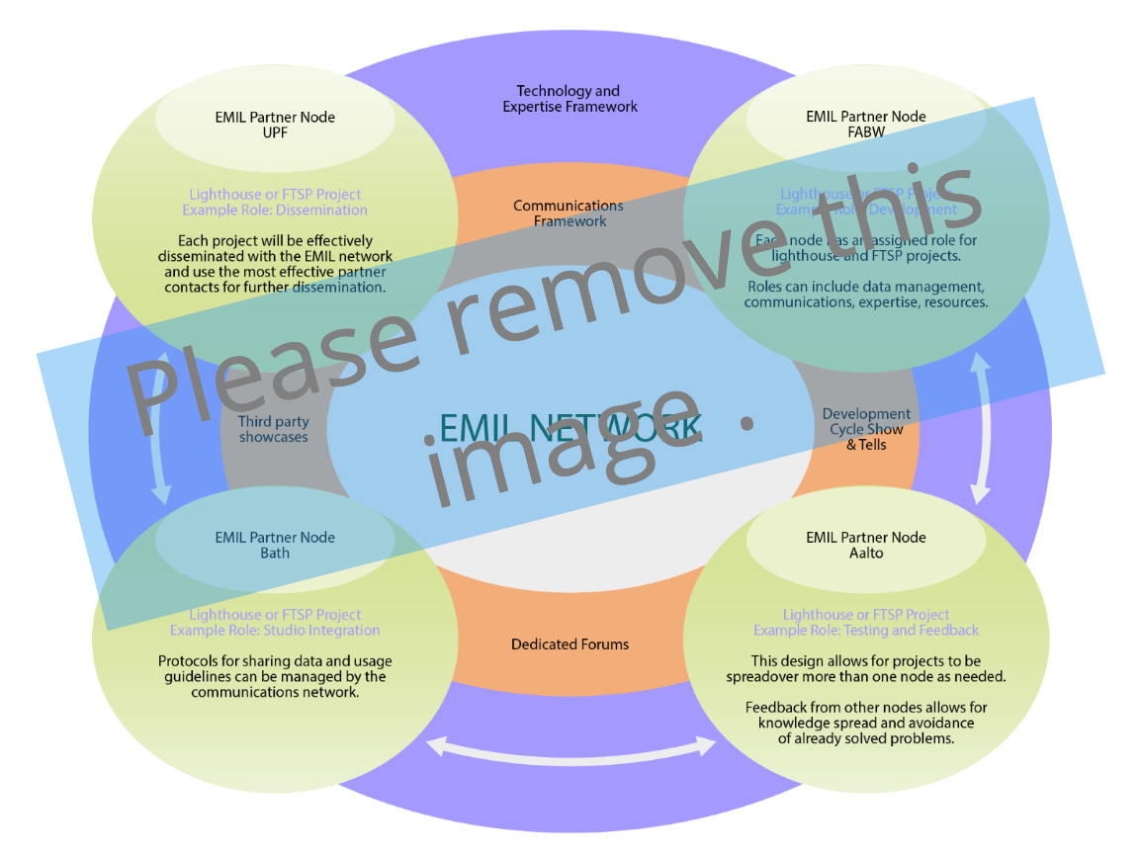
- [Describe the image a bit. (use ‘Image text’ style)]

Implementation and timeline

[Heading 2] Structure of the workplan
[i.e. Gantt chart: Work packages, Tasks, Milestones]

[Heading 2] Working group
[Please describe as exactly as possible the work, but please use profession titles and if necessary a short CV of the person WITHOUT the personal information. ]

[Heading 2] Support needed
[How are you going to fill the gaps of expertise, what kind of support you are hoping to get from the EMIL nodes. Are you going to use the facilities, tools and/or expertise the nodes could offer?]

Efficiency
[Budget, and use of the budget]

Budget
[You can replace the table below with similar budget made with the budget template you may have downloaded.]
Cost category | €
a. Direct personnel costs (salary + statutory side costs) sub-total
Employee cost
Second employee cost
Third etc
b. Purchase cost (sub-total)
Travels
Flights and train etc.
Accommodation
Subsistence
Goods and services (sub-total)
Consumables
Services
c. Other costs
d. Indirect costs (overhead) 25% of a+b+c(subocontracting not included)
e. Subcontract
subcontractor x
subcontractor y
Total

Impact, and sustainability
[How the activity will be used in the short and long-term.]

Links to EMIL Lighthouse projects
[Please name here the Lighthouse partner would best support your project: Smart Garments, Excergaming, Location Based XR, Magic Lantern. You can also have more than one lighthouse partners, or not at all.
How the lighthouse could be helpful to your or how you could benefit the lighthouse.

If the proposal is selected, additional documents will be requested during the negotiation phase to validate the information provided. Please make sure the information you provide in this form matches the information on supporting documents.
A person who can legally engage your organisation who will be involved in the grant signature and other administrative processes
The team leader/operational will be managing the implementation of the proposed project
[You can use footnotes to refer literature or for extra information important for evaluators]

